**River flow variation analysis of Indus Basin**

# Introduction

Indus river basin is the twelfth largest river in the world and longest river in Pakistan. It flows from the north Himalayan Mountains to the dry alluvial plains of Sindh in the south and into the Arabian Sea. In Pakistan, large areas of agriculture and other sectors depend on Indus River. However, the water flows and availability are influenced by water infrastructures such as dams, barrages and seasonal variation (Qureshi, 2011). The flow of the Indus river increases during monsoon season because of high glacier melting and high rainfall and the flows are five times more whereas the flow decreases in winter season (Ahmad, 2010). The river flow has decreased over many years because of the additional constructions of dams and barrages on Indus River. Thus impacting mainly the coastal ecosystem of the Indus delta where the river flows into the Arabian Sea (Kamal, 2008).

This study will investigate spatial and temporal variation of runoff for Indus River 2001-2013. The flow pattern at Kotri barrage, located at the downstream of Indus River, where the river flows into the Indus Delta will be mainly focused. The flow pattern for the major flood year 2010 will be analyzed to visualize the variation in the river flow.

# Literature review

The growing populations and increasing water demands in Pakistan have put a pressure in the Indus River system in Pakistan. The Indus River has failed to fulfill the environmental needs leading to a degradation of the riverine ecosystems. The lower Indus River Basin is having water shortages from several years. Studies have shown that the riverine forests along these regions have been declined (Hassan et al., 2019). The Indus Delta located at the lower Indus River Basin is a source of sustenance for coastal population and riverine ecosystem. It ranges from swamps, streams, wetlands to lagoons and mangroves forests. Mangrove forests cover largely area of the Indus Delta and are distinctive as the seventh largest mangrove forests in the world. Almost, 900,000 human populations live around the Indus Delta and the rural populations mostly rely on the mangrove ecosystem for their means of support through fishing. However, the reduction in the river flows in the Indus River has greatly impacted the Indus Delta through reduction in the environmental flows. This reduction of fresh water from the upstream Indus River to downstream causes seawater intrusion to the Indus Delta and also decline the coastal species as well as mangrove forests, thus degrading the coastal ecosystem (Salik, Hashmi, Zahdi, & Ishfaq, 2015).

The decrease in the river flow has mainly influenced the ecosystems and communities along the Indus Delta coast. The livelihoods of the coastal communities relying on fishing have been affected by lessening of fish species and population. For the sustainability of the Indus Delta ecosystem, Government of Pakistan has set a minimum environmental flow of 5000 cusec per day downstream Kotri barrage of Indus River, which needs to be maintained (Hassan et al., 2019). This study analyzed the Indus River flow from Tarbela to Kotri Barrage locations and visualize the flow downstream Kotri Barrage and focused more on the environmental flows downstream Kotri barrage.

# Methodology

## Study area

The Indus River Basin starts from the Tibetan Plateau (China) and drains through India, Afghanistan and Pakistan before it enters the Arabian Sea.

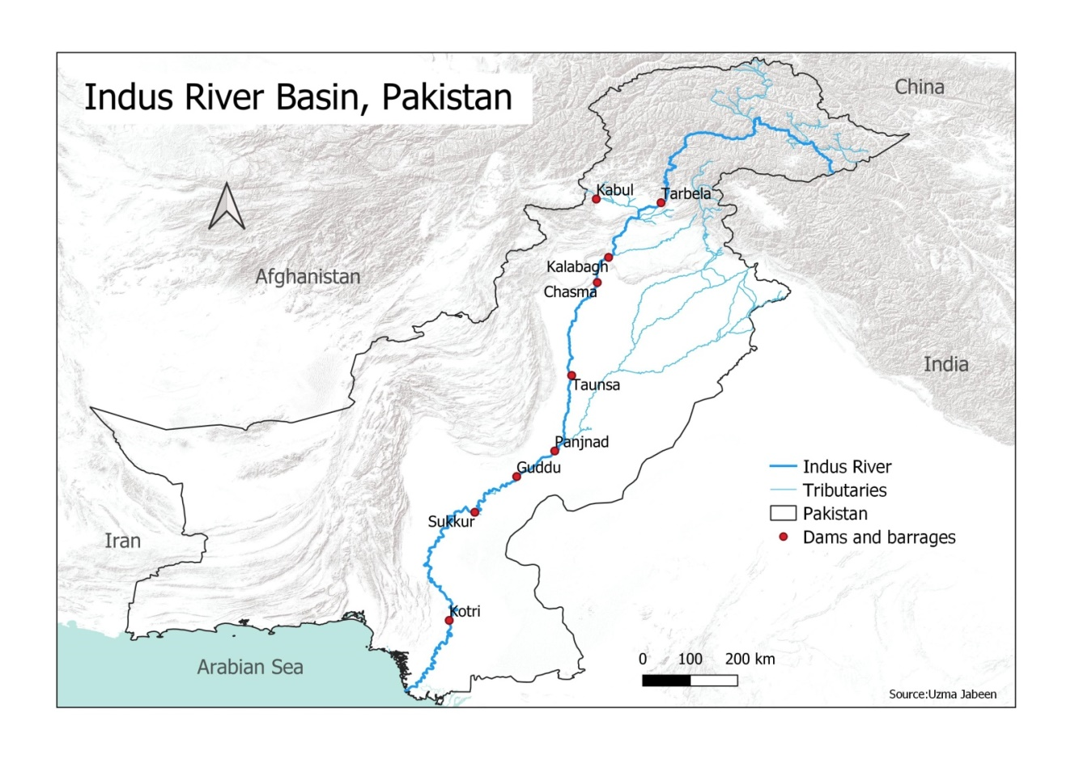

Figure 1. Map of the study area

The Indus River Basin starts from the Tibetan Plateau (China) and drains through India, Afghanistan and Pakistan before it enters the Arabian Sea. The Indus River Basin is a major water resources supplier for the agricultural sector in Pakistan; therefore, the variation in the runoff can impact many sectors which need to be investigated. Some of the major barrages and dam selected for the study are Tarbela Dam, Taunsa Barrage, Guddu Barrage, Sukkur Barrage, Kotri Barrage as shown in figure 1.

## Methods

The Indus river discharge data for the barrages and dams on the Indus River was collected from Sindh Irrigation and Drainage Authority (SIDA) and Kotri Barrage office. The data includes daily discharges of each location from 2001 to 2013. The R Studio software was used to calculate monthly and yearly mean values from the daily values. R package ‘lubridate’ was used for calculation of monthly and yearly mean values from daily data. Another R package ‘gglpot2’ was used for plotting graphs. QGIS software was used for mapping of the study area.

For this study, mean yearly flow for all locations were analyzed from 2001 to 2013. Tarbela dam located in the upstream of Indus River and Kotri barrage located at downstream were evaluated for flood year 2010 and non-flood year (2001 and 2009). Seasonal variation was also determined from these data. Daily river flow for Kotri barrage was plotted to visualize the overall river flow pattern from 2001 to 2013.

# Results

To determine the river flow trend from 2001 to 2013, mean yearly values were calculated from the daily discharge data using ‘lubridate’ R package as shown in figure 2. The plot shows that the overall mean yearly values vary among each location on the Indus River. The river flow at Taunsa dam is greater than other locations whereas the flow at Kotri barrage is lesser than other locations. Tarbela located at the upstream of the Indus River shows discharges less than Guddu which is located at the southern part of the Indus Basin. Also, Sukkur at the downstream have less discharges than Guddu and Tarbela except for the year 2010, Sukkur’s flow is high than Tarbela. This refers that Taunsa at the mid of the River Indus basin has higher flow but the flows reduced as it reaches to Guddu and Sukkur at the downstream but more reduced until it reaches to Kotri and Indus Delta. The flood year 2010 shows high river flow for all the locations and the flow decreases the next non-flood year 2011, which refers that the Indus river gets huge river flows during the flood and remains low during non-floods years especially in dry periods. It can be observed from the graph that the flow at Kotri barrage in 2010 has reached to 2400 m3/s whereas the flow in 2011 has immediately reduced to 800m3/s.

Figure 2. Mean yearly Indus River flow from 2001 to 2013

## Non-Flood years, 2001 and 2009

Figure 3 represents a graph of mean monthly river flow at Tarbela and Kotri for the year 2001. The flow has increased only in summer season or the Monsoon season (July, August, and September) for both locations. However, the flow at Kotri barrage remains lower than the environmental flow requirement (141.6 m3/s) during dry periods.

Similarly, another non-flood year, 2009 was also analyzed to observe the flow pattern at Tarbela and Kotri shown in figure 4. This plot also visualize that Kotri located at the downstream of the Indus River receives less water, the maximum flow has only reached to 2000 m3/s in the monsoon season whereas the flow at Tarbela has reached to 6300 m3/s. The flows during the dry period at Kotri remain low than the environmental flow.

Figure 3. Mean monthly flow at Tarbela and Kotri, 2001

Figure 4. Mean monthly flow at Tarbela and Kotri, 2009

## Flood year, 2010

In 2010, Pakistan experienced a major flood in monsoon season from north to southern part. The Indus River flows shows higher river flows at both Tarbela and Kotri especially in summer season (figure 5). The flow at Kotri has reached to 13000 m3/s from July to September, higher than Tarbela flows. This happened because of the flood in the monsoon season; Kotri located at the downstream of the Indus Basin received huge flows than its capacity. However, Kotri shows reduction in the flow during dry periods (Jan – May) whereas a slightly higher flow than the environmental flows from Oct – Dec.

Figure 5. Mean monthly flow at Tarbela and Kotri, 2010

## Daily flow at Kotri barrage

The daily river flow at Kotri shows high flow in 2010, where the flow has reached to 13000 m3/s whereas the flows in the remaining years the same flow as increasing in summers and decreasing in winter. The purpose of showing this plot (figure 6) is to observe the required environmental flow and the actual flow at the downstream of the Indus River. This plot shows that there is not a single year with enough river flow above the environmental flow at Kotri from 2001 to 2013.

Figure 6. Daily discharge of the Indus River at Kotri barrage

# Discussion and conclusion

The overall yearly flows show higher river flows in summer season/ monsoon season whereas the flows decrease during the dry periods. The overall yearly flow shows that Kotri located at the downstream of the Indus River receive less river water as compared to the upstream locations. The daily flow shows reduction in the flow especially during dry periods at Kotri barrage as compared to other locations not fulfilling the environmental flow limits for the Indus delta. This refers that Indus Delta at the downstream of Kotri barrage is not receiving enough water for the sustainability of its ecosystem because of the water storages located at upstream of the Indus Basin.

## Future goals and objectives

The time period chosen for this study is 2001 to 2013. The data prior to 2001 have missing values therefore not included in this study. A more detailed study can be conducted with extended time period to determine factors which are reducing the flow of the Indus River.

# References

* Ahmad, S. (2010). River Flows in the Indus Basin -I.
* Hassan, D., Burian, S. J., Bano, R., Ahmed, W., Arfan, M., Rais, M. N., … Ansari, K. (2019). An assessment of the Pakistan Water Apportionment Accord of 1991. *Resources*, *8*(3). https://doi.org/10.3390/resources8030120
* Kamal, A. (2008). Environmental Flows Indus River System in Pakistan.
* Qureshi, A. S. (2011). Water Management in the Indus Basin in Pakistan: Challenges and Opportunities. *Mountain Research and Development*, *31*(3), 252–260. https://doi.org/10.1659/MRD-JOURNAL-D-11-00019.1
* Salik, K. M., Hashmi, M. Z. ur R., Zahdi, W. ul Z., & Ishfaq, S. (2015). Ecological Assessment of the Indus Delta in Pakistan : A Desktop Analysis of Environmental Flow Requirements Ecological Assessment of the Indus Delta in Pakistan : A Desktop Analysis of Environmental Flow Requirements. *ResearchGate*, (December).